Step by Step Instructions for opening Project

1. Download the project. Optionally, It can be downloaded from GitHub link: <https://github.com/shubh2016shiv/CKD_prediction> as zip file as shown in snapshot below:

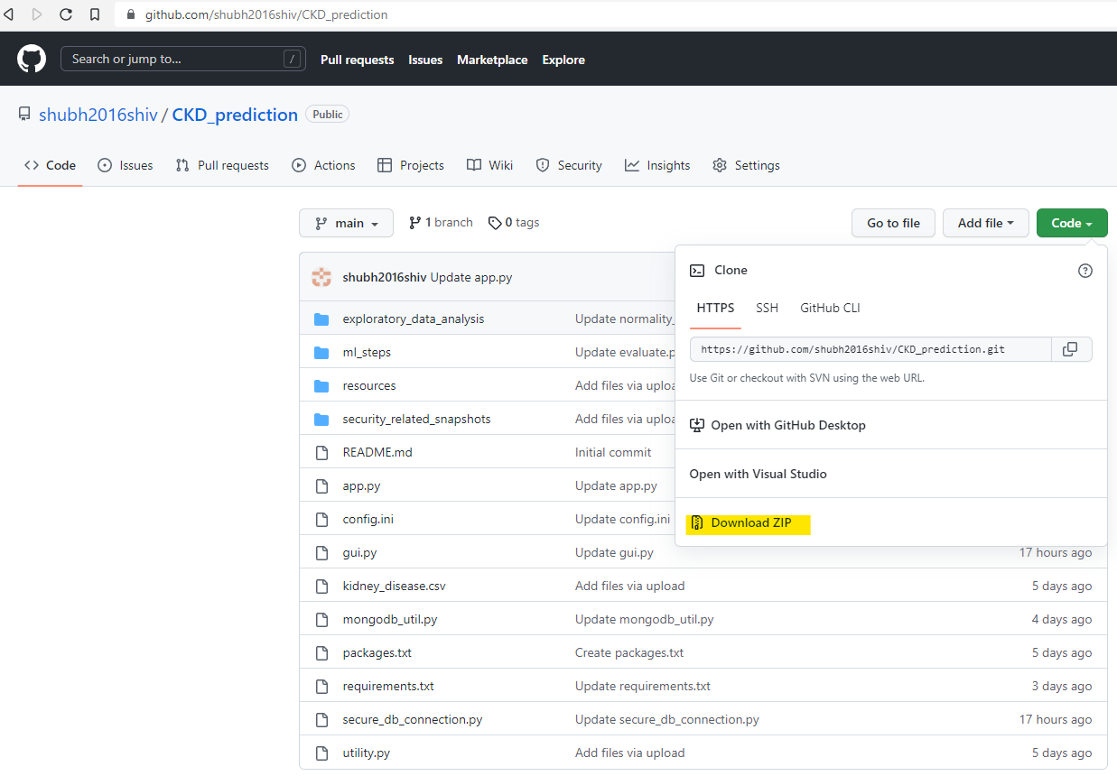

1. Keep the project in a folder on your computer and note down the path of the folder. For example: **C:\Users\Shubham Singh\OneDrive\Desktop\project\CKD_prediction-main**
2. Open ‘**Anaconda Prompt**’ application and navigate to same folder where project is there by using the command “**cd <project folder>**” (*replace the <project folder> with folder path where project is kept*) and run the python file ‘**gui.py**’ as shown in snapshot below.

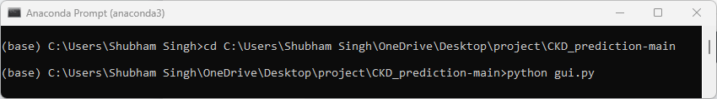

1. Below GUI program will show up. Use the credential given below for read-only authentication of accessing MongoDB and click on ‘Open Application’ button

*Username* : assessment_user

*Password* : Wel3g23U1Zxmf7dI

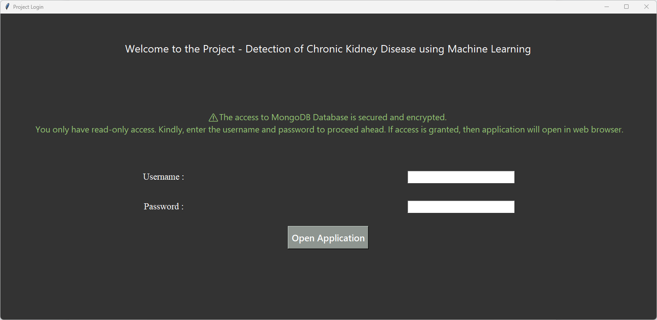

1. A website will open up on browser. Here, authenticate your access to this application using below credentials and click ‘Login’:

*Username : admin*

*Password : abc123*

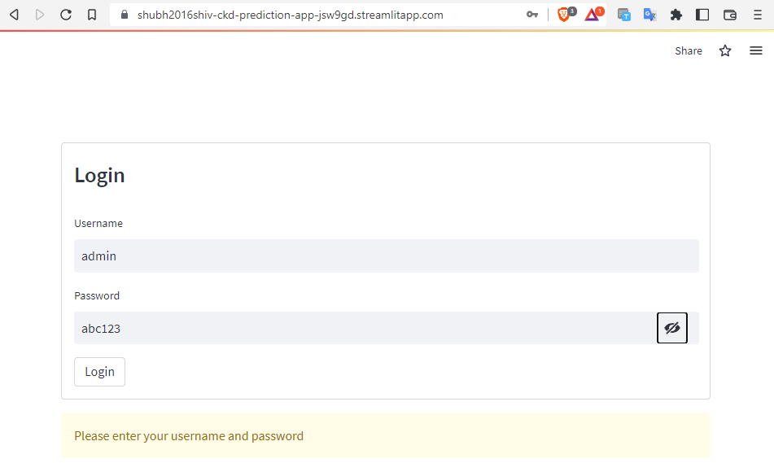

1. Finally Machine Learning application will open as shown below:

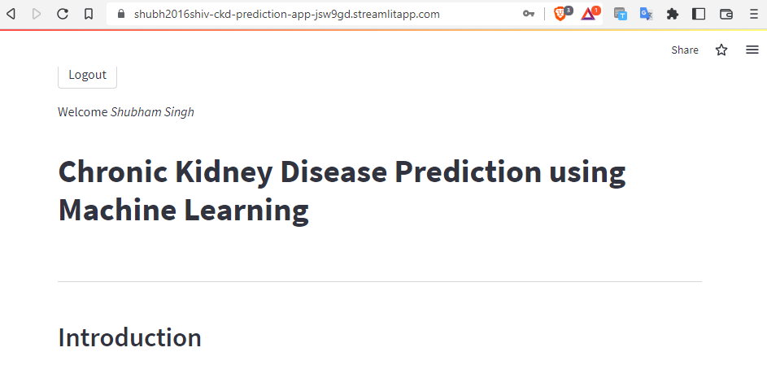

**Brief about Project Files**

Folders:

1. **exploratory_data_analysis :** This python package contains python files for performing the Exploratory Data Analysis and Data Visualization
2. **ml_steps :** This python package contains python files machine learning life-cycle steps
3. **resources:** Contains images and files required for the project
4. **security_related_snapshots :** Contains snapshot images to showcase how security is added to the machine learning application.

Files:

1. **credential_for_application_authentication.txt :** Contains username and password for application login.
2. **credential_for_mongoDB_authentication.txt** : Contains username and password for authenticating MongoDB Database access
3. **app.py :** Python file for web based machine learning application.
4. **config.ini** : Configuration File for application.
5. **gui.py :** Python file for Graphical User Interface that performs authentication for MongoDB and directs towards main machine learning application.
6. **mongodb_util.py :** It is python utility file for interacting with MongoDB database.
7. **requirements.txt :** It is file that contains all the python libraries used for this project.
8. **secure_db_connection.py :** Python file for securely authenticating and connecting to MongoDB.
9. **utility.py :** It is helper python file containing common functions used all across the project.